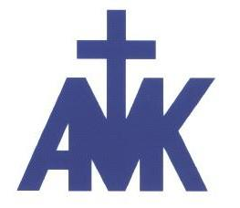
ANG MO KIO METHODIST CHURCH (TRAC)
BAPTISM AND MEMBERSHIP REGISTRATION FORM ADDENDUM
(CONFIDENTIAL)

FOR APPLICANTS UNDER 21 YEARS OF AGE
This form is to be accompanied with the Baptism and Membership Registration Form.

Dear Parent/Guardian,

We acknowledge your child/ward’s interest in becoming a member of our church and are very excited to have him/her with us!

Parent/ Guardian's Particulars (In case of emergency)
Name/ Relationship with Participant: | Contact (mobile and/or email):

Statement of Consent (for Participants below 21 years old)
I, ________________________ being the lawful parent/guardian of ______________________, hereby declare that permission is given to him/her to participate in the activities of the Baptism and Membership Course. I shall not hold the church responsible for any mishap or accident that may occur throughout the course.

I acknowledge that the Church is collecting my personal data and the personal data of my child/ward in this registration form in relation to my child’s/ward’s participation in the activities of the Baptism and Membership Course. I hereby consent to the Church collecting, using or disclosing my personal data and that of my child/ward to enable the Church to continue to provide services to me and/or my child/ward.

I also consent to the Church contacting me by telephone or sending text or email messages to me in relation to the Baptism and Membership Course.

By participating in the Baptism Rituals and Membership Class the participants are deemed to have consented to the collection, use and disclosure of his/her name, image, voice and/or likeness by Ang Mo Kio Methodist Church for the purposes of authentication, media broadcast, publications (printed and online platforms such as the church website and related social media platforms) and archival of materials which will remain the property of this Church.

_____________________________
Signature of Parent/Guardian | Date:

